Bài thực hành 6
Trần Văn Quyền
MSSV: 19574802010166

Câu 1:
import cv2
import numpy as np
import matplotlib.pyplot as plt

img = cv2.imread("D:\\Tran Quyen\\quyen.png")
anh_xam = cv2.cvtColor(img, cv2.COLOR_BGR2GRAY)
gauss = cv2.GaussianBlur(anh_xam, (5,5), 1)
thich_nghi = cv2.adaptiveThreshold(anh_xam, 255, cv2.ADAPTIVE_THRESH_MEAN_C, cv2.THRESH_BINARY, 11, 2)
kernel = np.ones((5,5), np.uint8)
dilated_img = cv2.dilate(anh_xam, kernel, iterations=1)
eroded_img = cv2.erode(anh_xam, kernel, iterations=1)
opened_img = cv2.morphologyEx(anh_xam, cv2.MORPH_OPEN, kernel)
closed_img = cv2.morphologyEx(anh_xam, cv2.MORPH_CLOSE, kernel)
cv2.imshow("Anh xam", anh_xam)
cv2.imshow("Thich nghi", thich_nghi)

plt.subplot(2, 3, 1)
plt.imshow(cv2.cvtColor(img, cv2.COLOR_BGR2RGB))
plt.title('Original Image')
plt.subplot(2, 3, 2)
plt.imshow(anh_xam, cmap='gray')
plt.title('Grayscale Image')
plt.subplot(2, 3, 3)
plt.imshow(dilated_img, cmap='gray')
plt.title('Dilated Image')
plt.subplot(2, 3, 4)
plt.imshow(eroded_img, cmap='gray')
plt.title('Eroded Image')
plt.subplot(2, 3, 5)
plt.imshow(opened_img, cmap='gray')
plt.title('Opened Image')
plt.subplot(2, 3, 6)
plt.imshow(closed_img, cmap='gray')
plt.title('Closed Image')
plt.show()

cv2.waitKey(0)
cv2.destroyAllWindows()

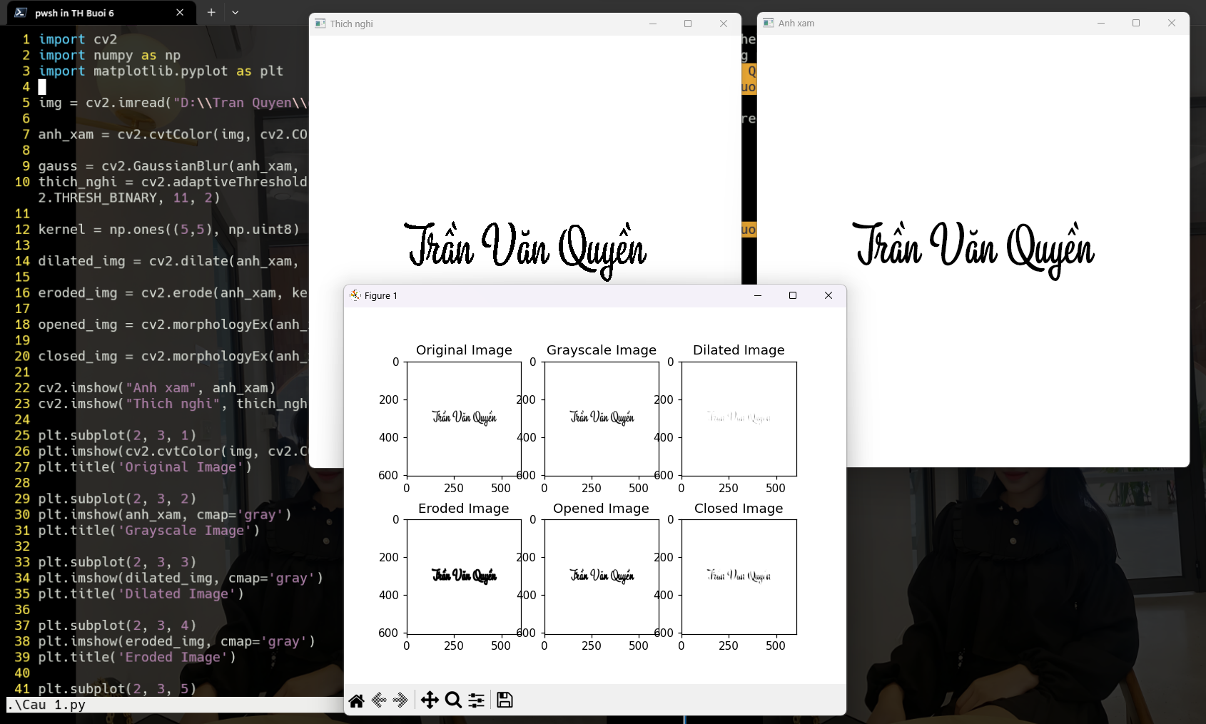
Câu 2:
import cv2
import numpy as np

img = cv2.imread('D:\\Tran Quyen\\quyen.png')
hsv = cv2.cvtColor(img, cv2.COLOR_BGR2HSV)
colors = ['H', 'S', 'V']
thresholds = {'H': [0, 179], 'S': [0, 255], 'V': [0, 255]}

for color in colors:
cv2.namedWindow(color)
cv2.createTrackbar(color+'Min', color, thresholds[color][0], thresholds[color][1], lambda x: None)
cv2.createTrackbar(color+'Max', color, thresholds[color][1], thresholds[color][1], lambda x: None)
h_min = cv2.getTrackbarPos(color+'Min', color)
h_max = cv2.getTrackbarPos(color+'Max', color)
print(color + 'Min:', h_min)
print(color + 'Max:', h_max)
cv2.imshow('image', img)

while True:
h_min = cv2.getTrackbarPos('HMin', 'H')
h_max = cv2.getTrackbarPos('HMax', 'H')
s_min = cv2.getTrackbarPos('SMin', 'S')
s_max = cv2.getTrackbarPos('SMax', 'S')
v_min = cv2.getTrackbarPos('VMin', 'V')
v_max = cv2.getTrackbarPos('VMax', 'V')

lower_hsv = np.array([h_min, s_min, v_min])
upper_hsv = np.array([h_max, s_max, v_max])

mask_hsv = cv2.inRange(hsv, lower_hsv, upper_hsv)
cv2.imshow('mask_H', mask_hsv)
mask = mask_hsv
cv2.imshow('mask', mask)
contours, hierarchy = cv2.findContours(mask, cv2.RETR_TREE, cv2.CHAIN_APPROX_SIMPLE)
for contour in contours:
x, y, w, h = cv2.boundingRect(contour)
cv2.rectangle(img, (x, y), (x+w, y+h), (0, 255, 0), 2)
cv2.imshow('result', img)
if cv2.waitKey(1) == ord('q'):
break

cv2.destroyAllWindows()
